**1970s Mid-Century Modern Chinoiserie La Barge Painted Rectangular Wall Mirror**

**Price: $1500**

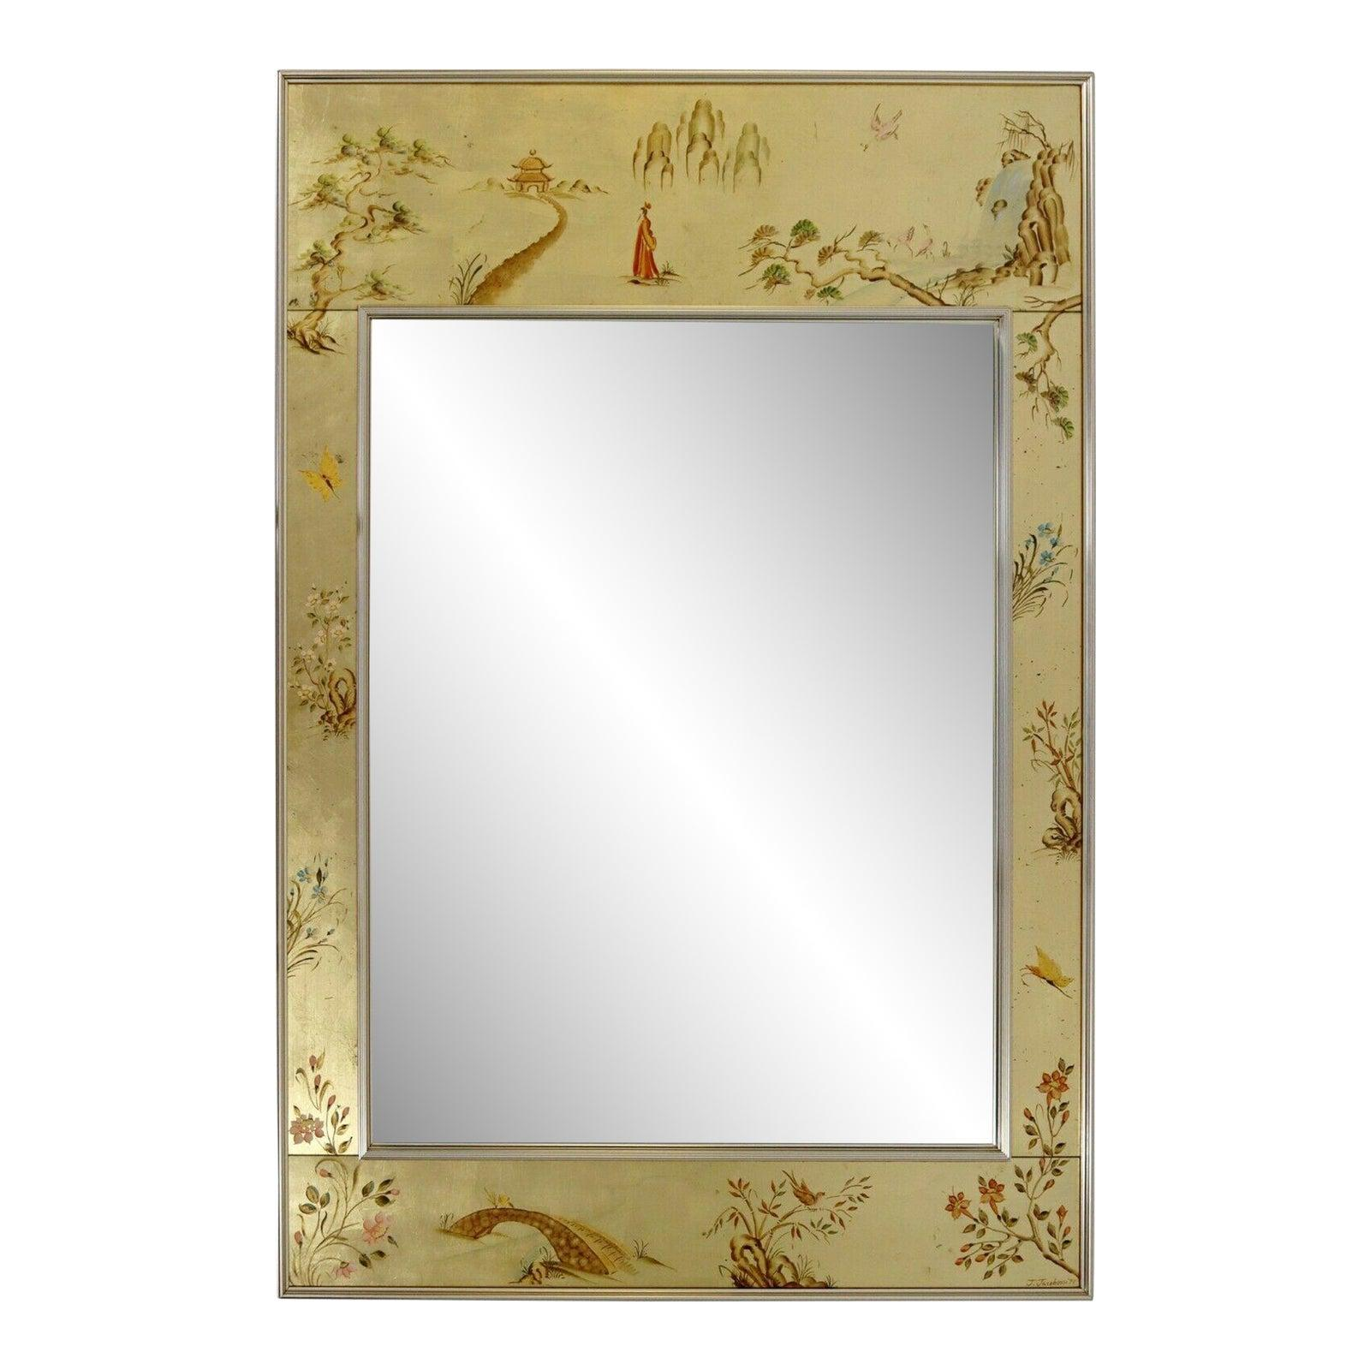

* CATEGORIES

Bathroom mirrors

* MATERIALS

Metal Bordered

* SHAPE

Rectangle

* BRAND

Viglacera